<!-- Google tag (gtag.js) --> <script async src="https://www.googletagmanager.com/gtag/js?id=G-5NMLK1DDQ5"></script> <script> window.dataLayer = window.dataLayer || []; function gtag(){dataLayer.push(arguments);} gtag('js', new Date()); gtag('config', 'G-5NMLK1DDQ5'); </script>
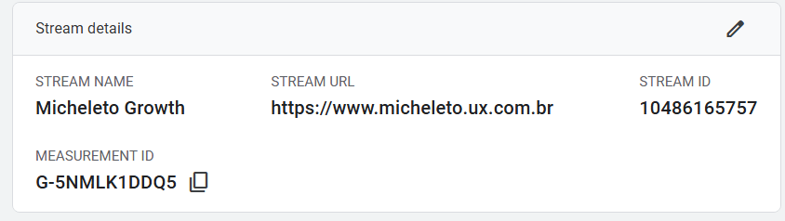
Stream Name
Micheleto Growth
Stream URL
https://www.micheleto.ux.com.br
Stream ID
10486165757
Measurement Id
G-5NMLK1DDQ5content_copy

